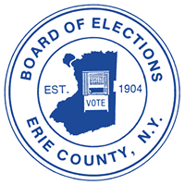

**BOE open 1-9 pm Saturday**

**for voter registration**

**For immediate release Contact: Derek Murphy** Friday, Oct. 4, 2024 716-858-6045

The Erie County Board of Elections at 134 West Eagle St., Buffalo, NY will be open 1-9 pm tomorrow, Saturday, Oct. 5 for voter registration.

“State election law requires boards of elections to provide additional registration hours one Saturday in October, commissioners Ralph M. Mohr and Jeremy J. Zellner said.”

The deadline to register for the Tuesday, Nov. 5 general election is Saturday, Oct. 26.

Registration forms are available at elections.erie.gov and at libraries, the Department of Motor Vehicles, and many other government offices and agencies.

For more information, call the Erie County Board of Elections are 716-858-8891.

#